Using Visual Schedules/ Routines at home

During this stressful time of sudden change all families and specially our children need some type of routine to establish normalcy, a way to get things done and a sense of security.
Consistent routines
- Bring comfort and consistency to children’s life (children need structure).
- Make their environment more predictable helpingthemfeelsafe, secure and confident.
- Help children gain understandingof everyday events and activities.
- Help children understand expectations (the child becomes accustomed to knowing when “play time” and “eating time” are). Child knows exactly what to expect.
- Help children being more compliant (the child begins tocooperate more and complete activities with less transition issues).
- Help children complete more tasks independently.
- Help creating a calmer household (because the child and other family members know what to expectanxiety and stress levels decrease).

** Repetition and predictability of routines fosters learning in childrenand help them to better regulate their bodies and emotions when their internal clocks are in synch from following a general rhythm each day**
Visual Schedules help children to better understand and remember routines.
A visual scheduleis a tool used to represent the activities that will occur in a giventime period. It can be used to communicate the overall flow of the day allowing the child to know what to expect and when.
A visual schedule can also show the steps within a task or activitybreaking it down into smaller more manageable steps.Examples: brushing teeth, toileting, dressing, etc.

Easy Ways to CreateVisual Schedules/Routines You Can Use With Your Child at Home

The following are different options for you to use according to your family needs/style. Choose the one that is more convenient for you.

Usingprovided images/pictures: At the end of this document you will find pictures we created for your use that represent the most common daily activities. Please see pictures! If you believe these pictures meet your needs and you decide to use them you can create a tangible schedule (printed on paper) or create a schedule in your phone.

If you have a printer you can:

- Print pictures.
- Cut pictures.
- Display pictures in the sequence you want your child to do these activities (you can arrange them either top to bottom or left to right order). You can tape these on a piece of poster board, cardboard, manila folder, a clipboard, etc.
- Post schedule in a strategic place at home at your child’s eye level.
- To transition your child to the next activity,bring your child to the schedule while saying “let’s go check your schedule”.
- Once in front of the schedulepoint to the picture of the activity while saying “is time for: breakfast for example.
- Then guide your child to the area where the activity is going to take place (in this case to the dining room).
- You could also bring the schedule to your child instead while saying “let’s see what’s next on the schedule” and pointing to the activity. **Bringing the schedule to your child will facilitate transitioning**.
To make it clear to your child that an activity is complete, before moving on to the next one you will remove the picture of the activity that has been completed, while saying: breakfast is finished and placing it in a bag/envelope labeled: finished. Then say “let’s see what’s next”.
Repeat process throughout the day for every activity until all activities are completed.
If you do not have a printer:
With your phone take a photo of each of the pictures and present it to your child one at the time while saying: “let’s see what’s next on your schedule”,“look it’s time for playing”(for example), then guide your child to the area were the activity is going to take place.
Repeat process until all activities are completed.

- Collecting images/pictures from Google:

- Go to Google
- Type key words to find a picturethat represent the activity you are looking for. Example: child brushing teeth, then click images(different options will appear on the screen).
- Scroll down until you find the image/picture that better fits your needs
- Click chosen picture
- Save picture in the folder you have created previously.
- Repeat the same procedure until you collect the pictures of all the activities you need.

If you have a printer you can:

- Print pictures (you can you can select a size of preference in the printer and make them all the same size for consistency).
Then repeat steps 2 to 8 already explained in the previous process; Please, see above (Using provided images/pictures).
If you do not have a printer:
With your phone take a photo of each of the pictures and present it to your child in the order you wish, one at the time while saying: “let’s see what’s next on your schedule”, “look it’s time for playing” (for example), then guide your child to the area were the activity is going to take place.
Repeat process until all activities are completed.

- Creating your own images/pictures with your cell phone camera:
With your phone take a photo of your child doing different activities until you gather images that represent all the activities you want your child to do. Bring the phone to your child for every transition, present the activities to the child in the order you wish. Thenfor each activity/transition your would say,“let’s see what’s next on your schedule”, “look it’s time for breakfast” (while you are showing him the picture of him eating), then guide your child to the area were the activity is going to take place.
Repeat process until all activities are completed.

Below you will find examples of schedules and photos of activities we have put together for your use; please see!

Daily Schedule example (using provided pictures)

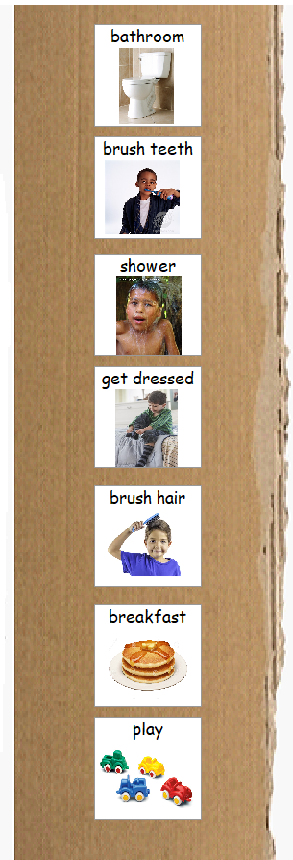

Tooth Brushing Routine example (using printed photos of the child)

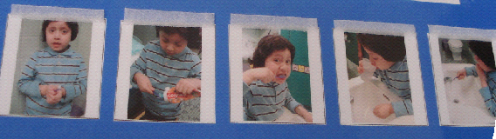

Daily Schedule example (using Google photos taken/downloaded onto phone) Presented on the phone one by one.
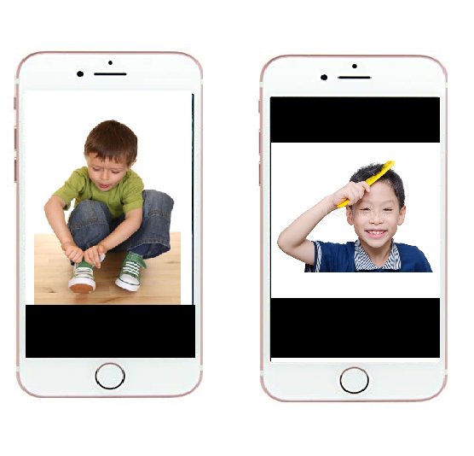

See below for pictures for your use.
